**Rajshahi University of Engineering & Technology**

**Course Name:** Sessional based on CSE-3109

**Course code:** CSE-3110

**Submitted to:**

Sadia Zaman Mishu

Assistant Professor

Dept of Computer Science and Engineering,RUET

**Submitted By:**

Asfaq Ahmed Siddique

Roll:1803028

Section:A

Dept of Computer Science and Engineering,RUET

**Date of submission:** 02 August,2022

**Experiment Name:**Input a string and reverse it and check if it is palindrome or not.

**Objectives:**

* Learn to use of string operations in in assembly language

**Source Code:**

.MODEL SMALL

.STACK 100H

.DATA

STRING DB DUP(100), '?'

STRING1 DB 'String is palindrome', '$'

STRING2 DB 'String is not palindrome', '$'

STRING3 DB 'Main string only alphabet:', '$'

STRING4 DB 'Main string only alphabet reversed:', '$'

.CODE

MAIN PROC FAR

MOV AX, @DATA

MOV DS, AX

CALL Palindrome

MOV AH, 4CH

INT 21H

MAIN ENDP

Palindrome PROC

MOV SI,OFFSET STRING

INPUT:

MOV AH,1

INT 21H

CMP AL,13

JE LOOP1

MOV [SI],AL

INC SI

JMP INPUT

LOOP1 :

MOV AX, [SI]

CMP AL, '$'

JE LABEL1

INC SI

JMP LOOP1

LABEL1 :

MOV DI,OFFSET STRING

DEC SI

LOOP2 :

CMP SI, DI

JL OUTPUT1

MOV AX,[SI]

MOV BX, [DI]

CMP AL, BL

JNE OUTPUT2

DEC SI

INC DI

JMP LOOP2

OUTPUT1:

LEA DX,STRING1

MOV AH, 09H

INT 21H

RET

OUTPUT2:

LEA DX,STRING2

MOV AH,09H

INT 21H

RET

Palindrome ENDP

END MAIN

**Output:**

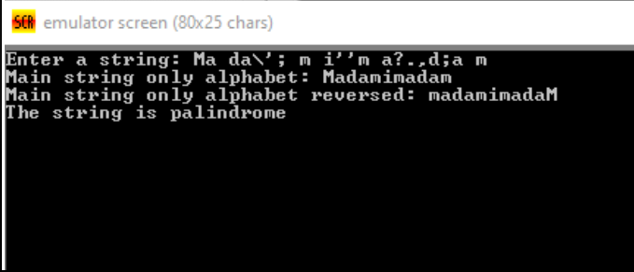

**Conclusion:**

Here we use string operations to check whether a string is palindrome or not